Part 1



Part 2

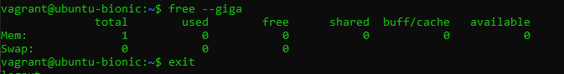

Part 3

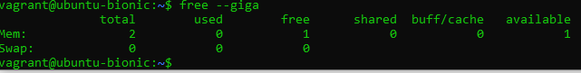

Part 4

